Peer-to-Peer (P2P) Systems
# Source: AI Source: Provided by: [Data Path: Persons Table -> ID Column: 1, Name_En Column: Motasem Essam] -> From: [ChatGPT] on [1/16/2026]
A Peer-to-Peer (P2P) system is a type of distributed system in which all nodes (peers) are equal and can act as both clients and servers at the same time.
There is no central server—peers communicate directly with each other to share resources.

Definition
# Source: AI Source: Provided by: [Data Path: Persons Table -> ID Column: 1, Name_En Column: Motasem Essam] -> From: [ChatGPT] on [1/16/2026]
In a P2P system:
- Every node can request and provide services
- Resources (files, data, computing power) are shared directly
- The system is decentralized

Architecture Diagram
# Source: AI Source: Provided by: [Data Path: Persons Table -> ID Column: 1, Name_En Column: Motasem Essam] -> From: [ChatGPT] on [1/16/2026]
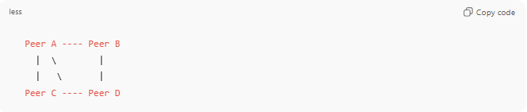
Peer A ---- Peer B
| \ |
| \ |
Peer C ---- Peer D

Key Characteristics
# Source: AI Source: Provided by: [Data Path: Persons Table -> ID Column: 1, Name_En Column: Motasem Essam] -> From: [ChatGPT] on [1/16/2026]
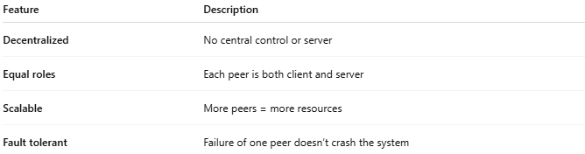
Feature | Description
Decentralized | No central control or server
Equal roles | Each peer is both client and server
Scalable | More peers = more resources
Fault tolerant | Failure of one peer doesn’t crash the system

How It Works
# Source: AI Source: Provided by: [Data Path: Persons Table -> ID Column: 1, Name_En Column: Motasem Essam] -> From: [ChatGPT] on [1/16/2026]
- A peer joins the network
- It connects to other peers
- Requests and responses are exchanged directly
- Data/resources are distributed among peers

Types of P2P Systems
# Source: AI Source: Provided by: [Data Path: Persons Table -> ID Column: 1, Name_En Column: Motasem Essam] -> From: [ChatGPT] on [1/16/2026]
a) Pure P2P
- No central authority
- All peers equal
Example: Early Gnutella
b) Hybrid P2P
- Central server for discovery, peers for data transfer
Example: BitTorrent (tracker-based), Skype (early versions)

Real-World Examples
# Source: AI Source: Provided by: [Data Path: Persons Table -> ID Column: 1, Name_En Column: Motasem Essam] -> From: [ChatGPT] on [1/16/2026]
- File sharing: BitTorrent
- Blockchain: Bitcoin, Ethereum
- Communication: Skype (P2P calls)
- Distributed storage: IPFS

Advantages
# Source: AI Source: Provided by: [Data Path: Persons Table -> ID Column: 1, Name_En Column: Motasem Essam] -> From: [ChatGPT] on [1/16/2026]
- No single point of failure
- Highly scalable
- Cost-effective (uses peer resources)

Disadvantages
# Source: AI Source: Provided by: [Data Path: Persons Table -> ID Column: 1, Name_En Column: Motasem Essam] -> From: [ChatGPT] on [1/16/2026]
- Difficult to manage and secure
- Data consistency is hard
- Performance depends on peer availability

Comparison: Client-Server vs P2P
# Source: AI Source: Provided by: [Data Path: Persons Table -> ID Column: 1, Name_En Column: Motasem Essam] -> From: [ChatGPT] on [1/16/2026]
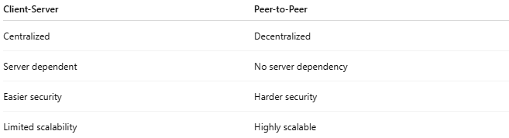
Client-Server | Peer-to-Peer
Centralized | Decentralized
Server dependent | No server dependency
Easier security | Harder security
Limited scalability | Highly scalable

Simple Analogy
# Source: AI Source: Provided by: [Data Path: Persons Table -> ID Column: 1, Name_En Column: Motasem Essam] -> From: [ChatGPT] on [1/16/2026]
- Client-Server: Students ask a teacher for notes
- P2P: Students share notes directly with each other

